EATING HEALTHY TIPS

ANTIOXIDANTS 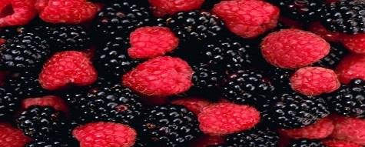

Antioxidants are either man-made or natural. They MAY prevent or delay some types of cell damage. Antioxidants are found in many foods, including fruits and vegetables. They are also available as dietary supplements.
Vegetables and fruits are rich sources of antioxidants. There is good evidence that eating a diet with lots of vegetables and fruits is healthy and lowers risks of certain diseases. But it isn't clear whether this is because of the antioxidants, something else in the foods, or other factors. Always check with your doctor for any questions regarding your child’s diet.
An easy way to help your children eat healthy is by making them a smoothie. If you can’t find fresh fruit then buy frozen fruit from your grocery store.
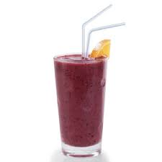
SMOOTHIES ARE A GREAT WAY TO PROVIDE A HEALTHY MEAL FOR YOUR CHILDREN. SMOOTHIES DON’T REQUIRE CHEWING AND THE NUTRITION WILL ABSORB MORE QUICKLY INTO THE BODY. (2012)

RESOURCES:
National Center for Complementary and Alternative Medicine of the National Institute of Health. http://nccam.nih.gov/health/antioxidants/introduction.htm
Happily Hungry: Smart Recipes for Kids with Cancer (2012) by Danielle Cook Navidi

